**Macro Walkthrough:**

The macro would help in merging all the database files stored in one particular folder into another file called MergedDatabase1.accdb.

Table transformation:

[1-WordlistMetadata] 🡪 WordlistMetadata

[2-SpeakerMetadata] 🡪 SpeakerMetadata

[3-ConceptList] 🡪 ConceptList

[4-WordlistTemplate] 🡪 WordlistTemplate

[5-NounClasses] 🡪 NounClasses

[5-VerbGroup] 🡪 VerbGroup

[NAC-Abar-2] 🡪 All user tables with citations gets transformed to User_Citation Table

Two additional tables are added in MergedDatabase1.accdb table:

File_Master: It keeps track of the files that are being added to the MergedDatabase1.accdb file.

Language_Table: This is a static table and it stores all languages included in the files

Macro Flow:

1. Add all the files to a particular folder. Copy the file path of that folder and include it in the macro code.
2. You can access the macro code by opening the macro file. Click on Create then click on Visual Basic (highlighted in the picture).

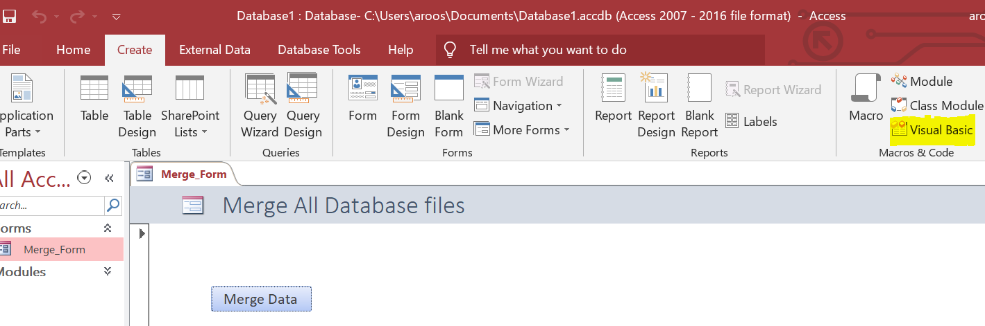

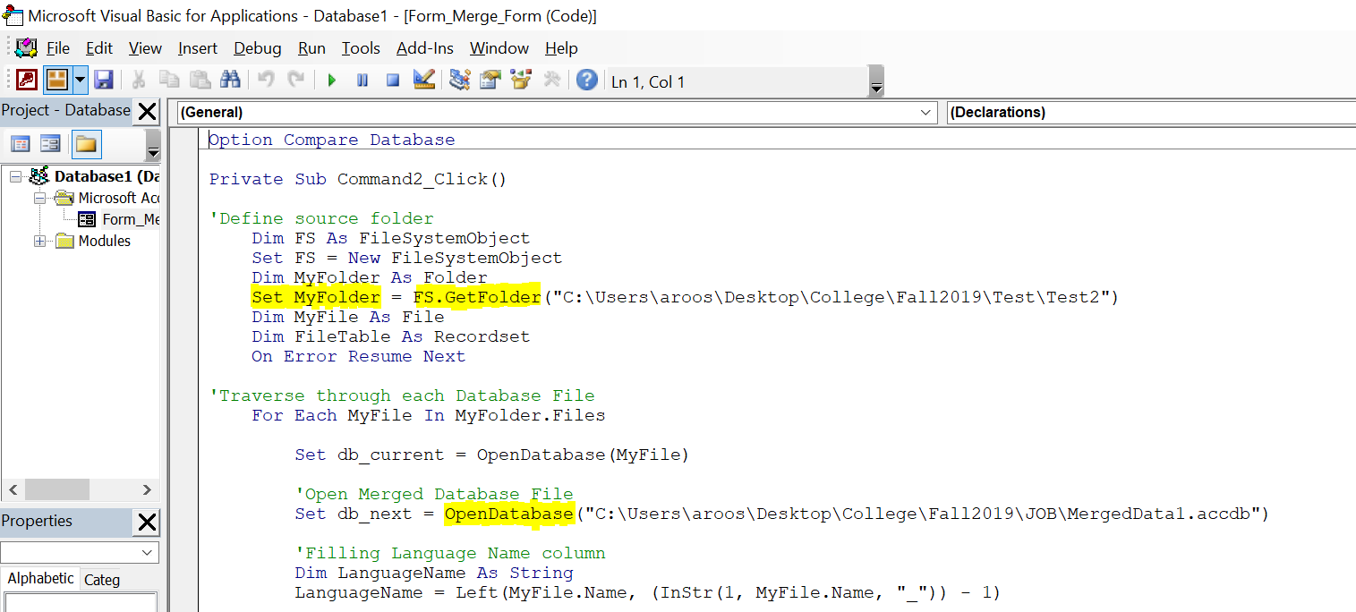

1. Change the folder path (highlighted in the picture) and MergedData1.accdb (highlighted in the picture) file path.
2. If there is any change/addition to the columns in any of the tables then add/edit the columns in those columns in the macro too. Just add it in the same manner as existing columns.

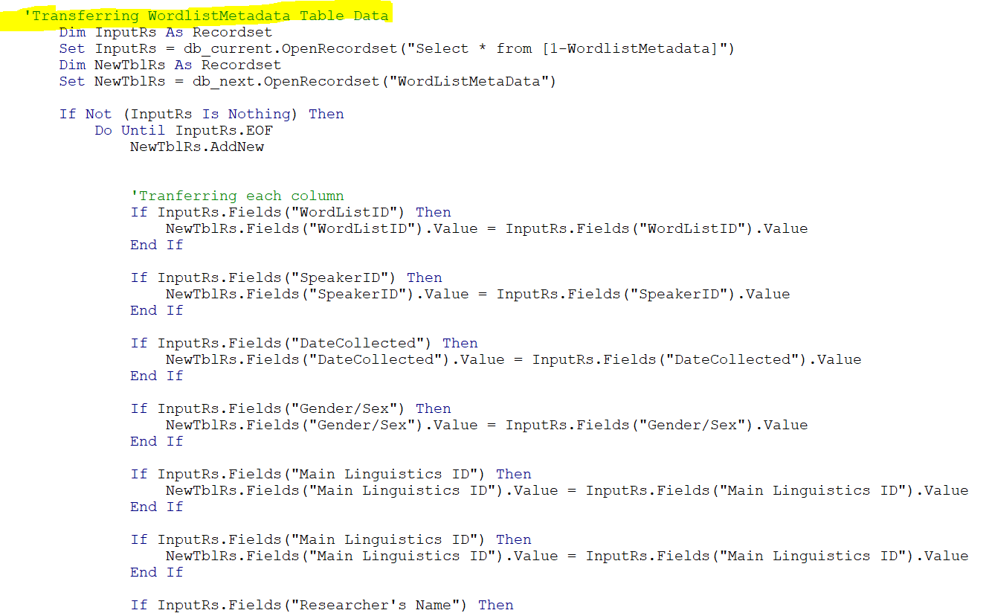

1. Please refer to attached excel file to know the column names and spellings. Any misspelling might lead to loss of data for that column in the new merged DB.
2. After editing the macro file, save it and run macro again.
3. If there are any duplicate files, then the macro gives you an option to overwrite files. It judges duplicity on the basis on SpeakerName and Language combination.

MergedData1: Relationship Diagram

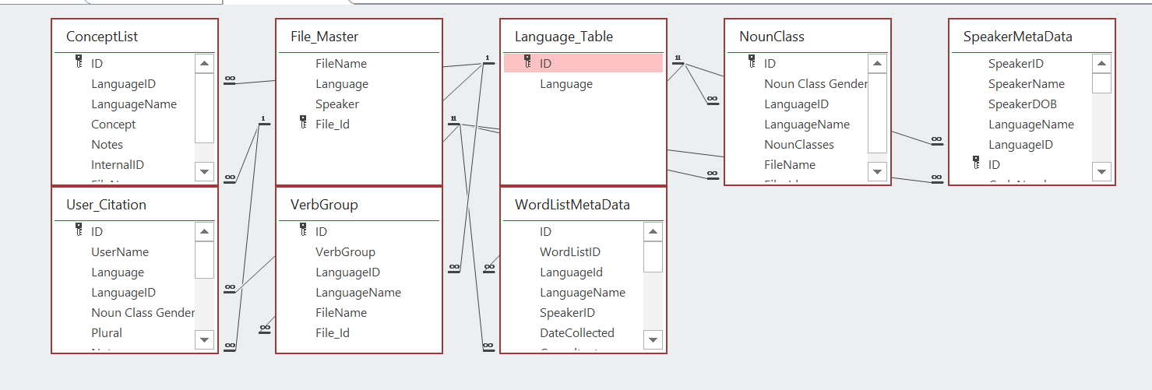

1. After transferring all the data to MergedData1.accdb file. Use the following link to convert .accdb file to .sql file.

<https://www.rebasedata.com/convert-access-to-mysql-online>

Mac users need to use this link. Windows user can download BullZip software to do the same.

We need to convert .accdb file to SQL file because iPage server doesn’t allow any other way to upload SQL data on its server.

**WebProject on IPage Server:**

1. Click on the link to access the PHP project and all the associated files.

<https://www1.ipage.com/controlpanel/FileManager/>

1. Upload SQL Script to WebProject on IPage server by accessing this link

<https://mysqladmin.ipage.com/mysqladmin/index.php>

1. Click on Import tab and choose the updated .sql file
2. 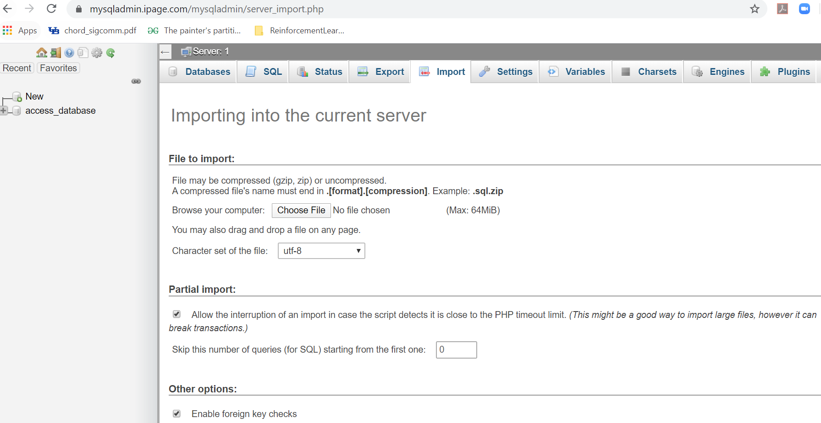Click on go and refresh website to access changes.

Run the macro with MergedDatabase1.accdb closed